Nick Layman

Project 3 – Farkle GUI

­­­­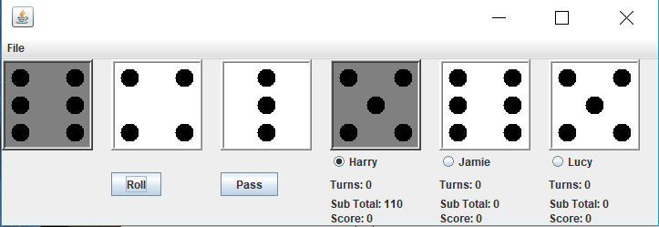

"I pledge that this work is entirely mine, and mine alone (except for any code provided by my instructor).”

X_________________________________

I spent 4 hours and 40 minutes working on this project from October 30 to November 5, 2018 reading the assignment, writing the code, fixing errors, writing proper documentation, making the code look more elegant, and making this write up.